**Assignment 1**

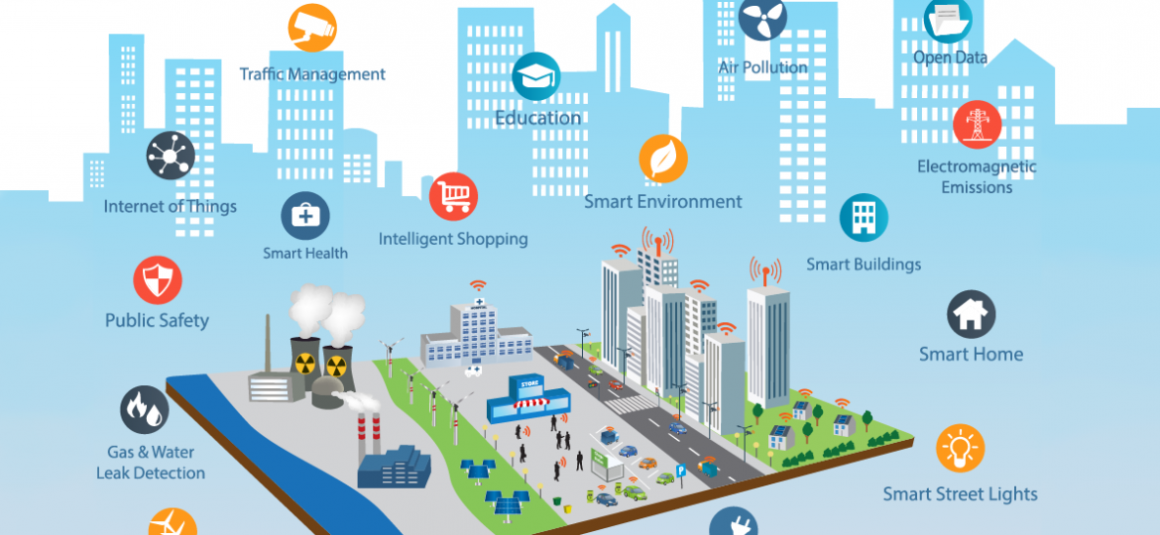

In a smart city, we are using devices like desktop, laptops, mobile phones etc to perform our daily tasks, access information etc. Some of the smart city automated systems are prominent from the figure above. You are required to visualize the daily activities of a system manager working in a software house, living in a smart home fitted with wifi controlled devices and answer the following questions in the light of knowledge you obtained in chapter 1 and 2 of this Operating Systems course :

Q1. Examples of computing machines he uses: /10

1. At home
2. In office
3. During commute

Q2. Give the name of operating systems (centralized/distributed), he might be using and the reason to use that particular system: /10

1. At home
2. In office
3. During commute

Q3. The architecture of machines , he is using (single core, multicore, symmetric, asymmetric processing) and why?: /10

1. At home
2. At office
3. During commute

Q4. The examples of computing environment he interacts , the purpose of interaction: /10

1. At home
2. At office
3. During commute

Q5. Give example of task automation that can help a banker /5

1. At home
2. At office

Q6. List two of the APIs that are used frequently by most of the drivers using mobile services during driving. /5

Q7. Differentiate: /10

1. Arduino vs Raspberry Pi (in terms of memory management and process management)
2. iOS vs Android ( in terms of Graphical User Interface, APIs, system development languages)
3. emulation vs simulation with example

Q8. Why applications are operating system dependent? Explain briefly. /10

Q9. Pick one of the applications shown in smart city and discuss its architecture, computing environment, communication needs in terms of operating system concepts. /30